Library Management System

1. **Scope**

Authentication System

Book Management

Book Borrow Operations

Book update details Management

1. **Functional requirements**

**Registration and login** - users can register and login using email and passwords.

**CRUD operations for books** - Admins can create, read, update, and delete book details in the system.

**Update availability status** - Admins can update availability status manually

**View books** - Admins can view books details with their status as borrowed or not.

**Mark as returned** - Admins can mark borrowed books as returned.

**Borrow books** - Readers can view books and borrow books.

**Borrow details** - Readers can view borrowed books.

1. **Nonfunctional requirements**
2. **ER Diagram**

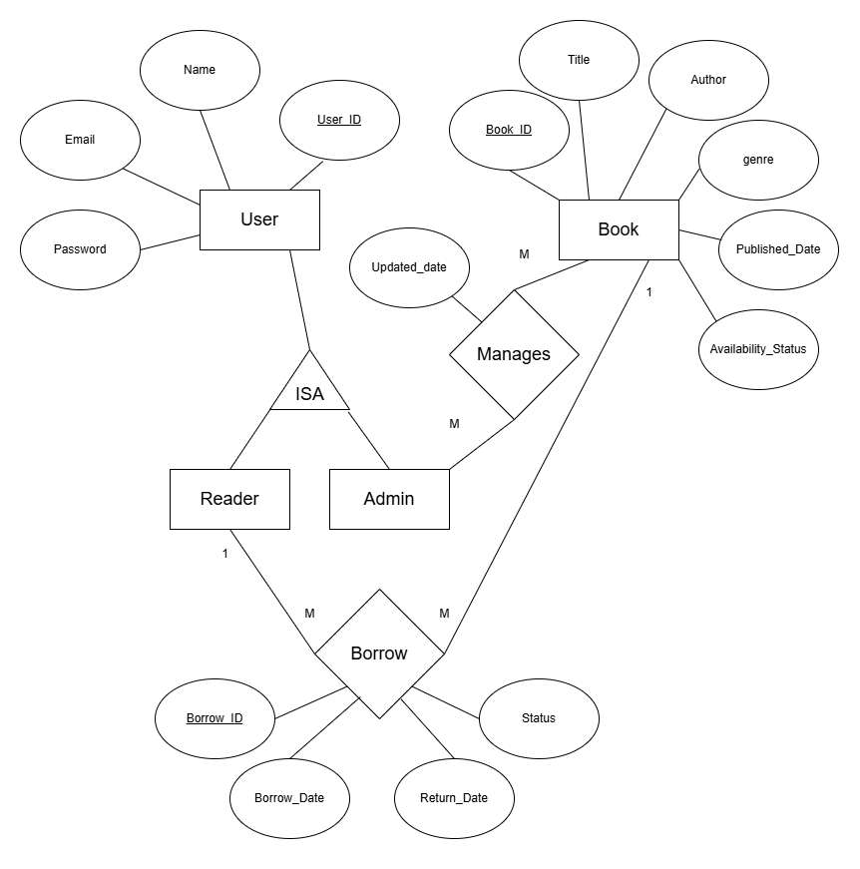

4.1 ER Diagram for Library Management System

1. **Normalization**

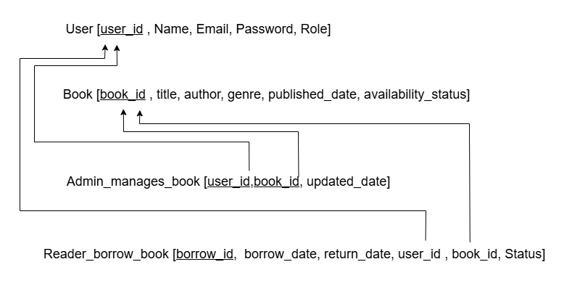

5.1 Mapping for Library Management System

1. **User Case Diagram**

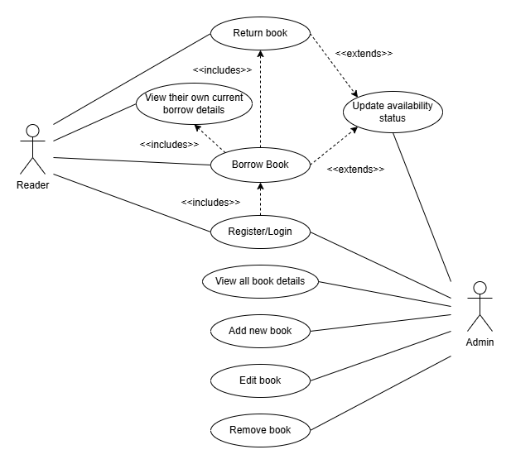

6.1 User Case Diagram for Library Management System

1. **Architectural Diagram**

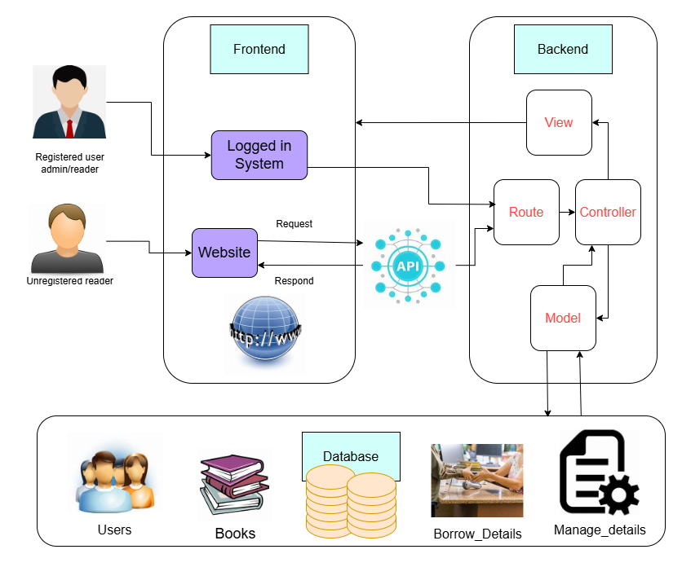

7.1 Architectural Diagram for Library Management System